PROJECT REPORT

NEW YORK UNIVERSITY

TANDON SCHOOL OF

ENGINEERING

DEPARTMENT OF COMPUTER SCIENCE

**Submitted By:**

Aman Mahato (N-12198142)

Introduction: goNYU

goNYU is a free web application and social networking website for Outdoor Enthusiasts, particularly focused for NYU Students. This web application is very similar to Facebook or Timeout where people of similar interest can interact with each other and can plan their trips together. This could be a best platform for students at NYU who are looking for someone with similar interest and wants to hangout together or share some of their experience regarding any trips. They can also share their pictures and put description in it to make it more expressive. At this point of time, it has very limited features like making friends, commenting on other pictures, looking into other interests, checking other registered user’s profile, searching for any particular location. In coming few days, I am also planning to integrate messaging system within this application.

Redesign of Schema

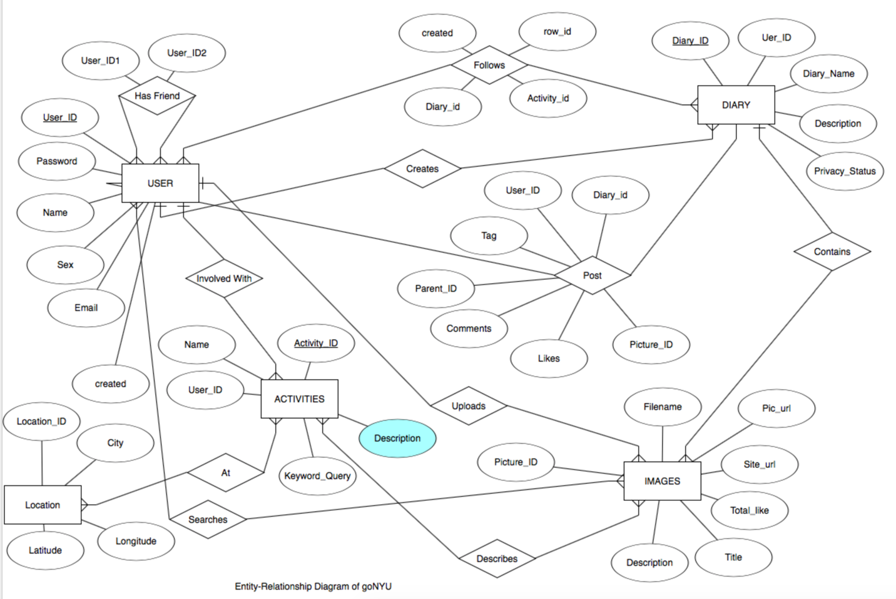

How It Works?

The way this web app works is, first we need to make a user account. For that we have to sign up. This stores the user information and creates a profile for him/her. The sign up page looks some thing like this.

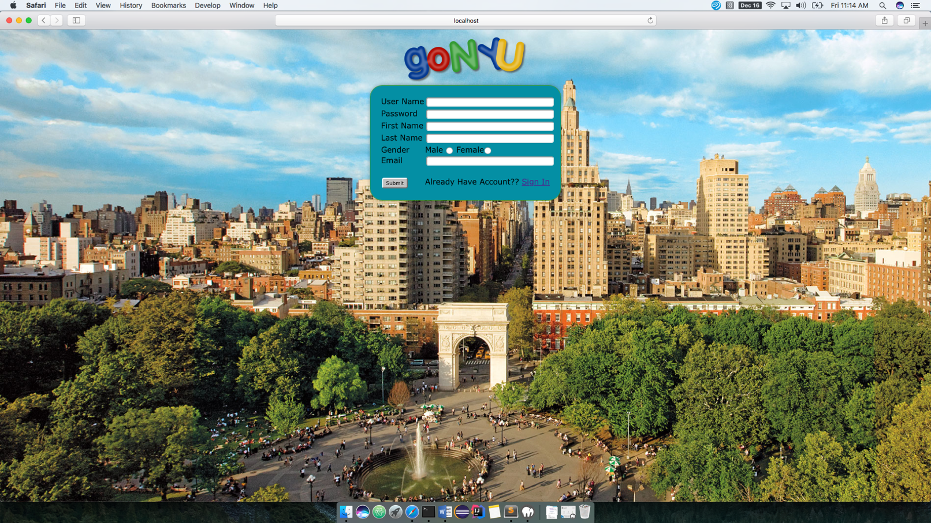

In sign up page, potential user has to fill all the necessary fields which includes user name, password, first name, last name, gender and email. If user has already signed up but if h/she some how ends up at this page, there is option to go to login page as well which has a hyperlink to login page. Once the user sign up for the new account, it directs to the login page as shown below:

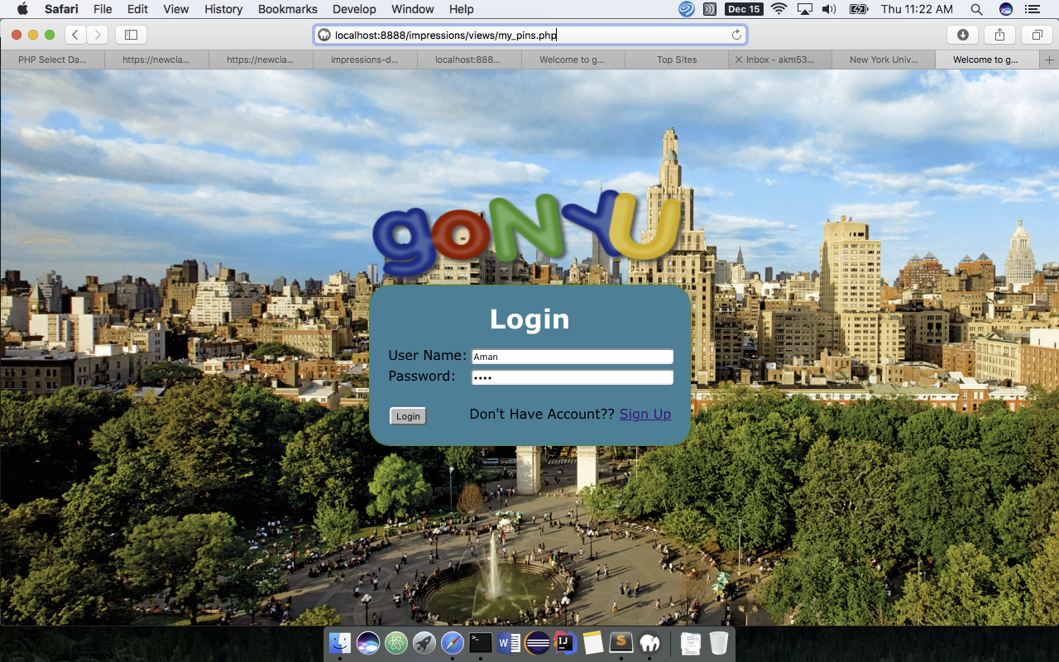

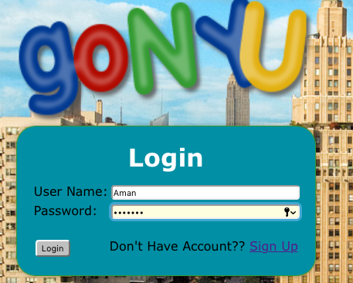

Here, the user has to enter the user name and the password. These credentials are then tallied with the one stored in the database for the security and validation purpose. If they are a match, the user is allowed to log in and they are directed to the landing page where user can see all the posts he/she has made in the past. If h/she is a new user, the landing page will be empty for the first time until a new activity/pictures are uploaded.

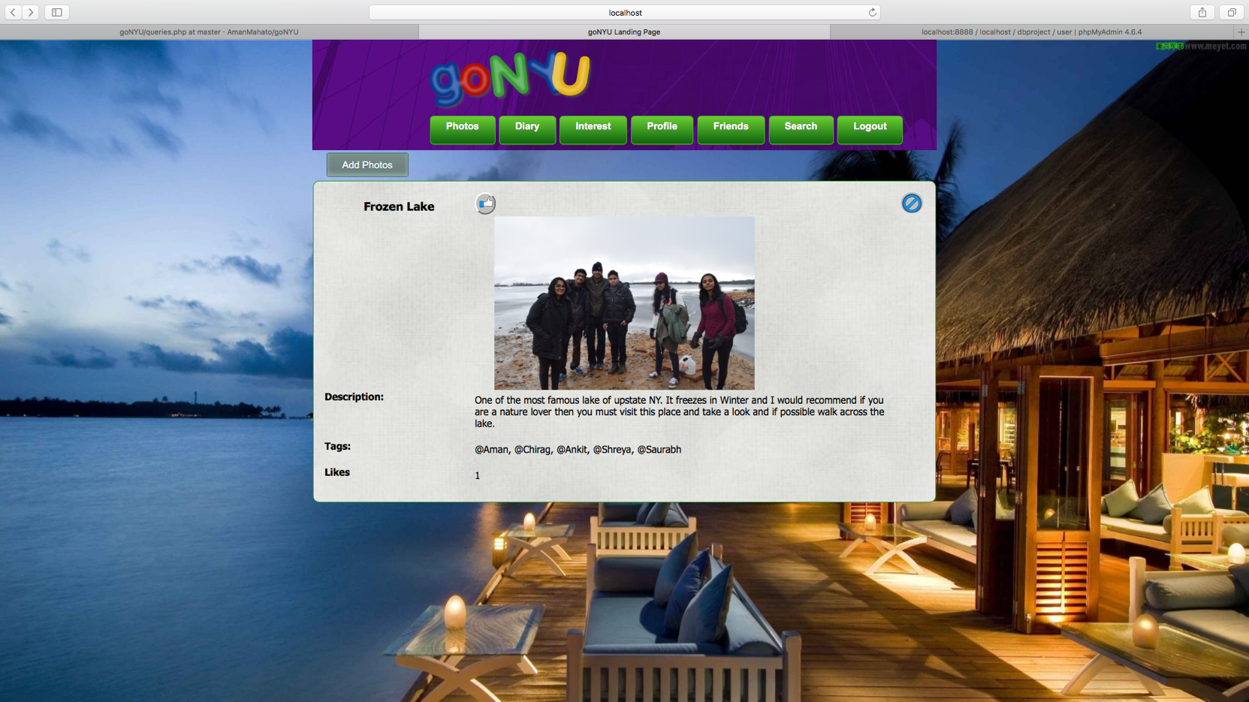

This is very similar to the Facebook feedback with only difference being here, the feed is local ie. all the activity shown in landing page belongs the user’s own account and not from the other user account.

Now to post some thing, like the picture or activity, first the user have to create a new Diary. This Diary can be thought of something as a collection or an album which here is used to organize all the events or activites of one type at one place. So to create a new activity, user have to first click on the Diary tab at the top and has to provide the the Diary name. which can or can not be unique, and then it also asks for the small description which describes what exactly the diary is about. It has a privacy setting as well which controls the behavour of who can view this diary. There are three options in the privacy setting viz, Friends, public and Private meaning, if the setting is set to friends, then only frind can view it, if its public then anyone can view it whi has signed up for this app and if its set to private then no once can view it. It will be restricted to only the owner who created it.

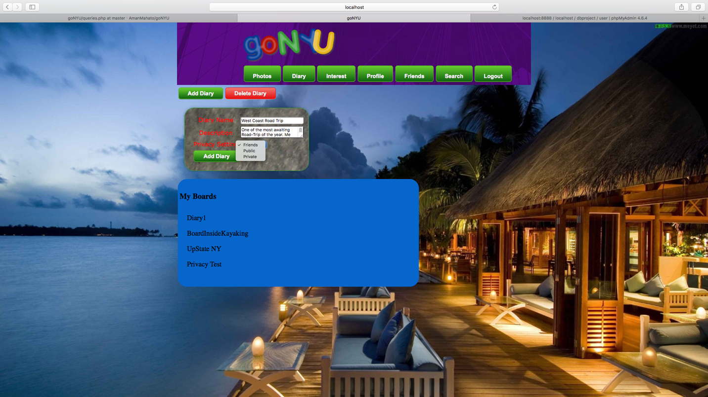

Once the form is submitted, it will create an empty diary. This can be verified by the name saying West Coast Road Trip in the My Diary List

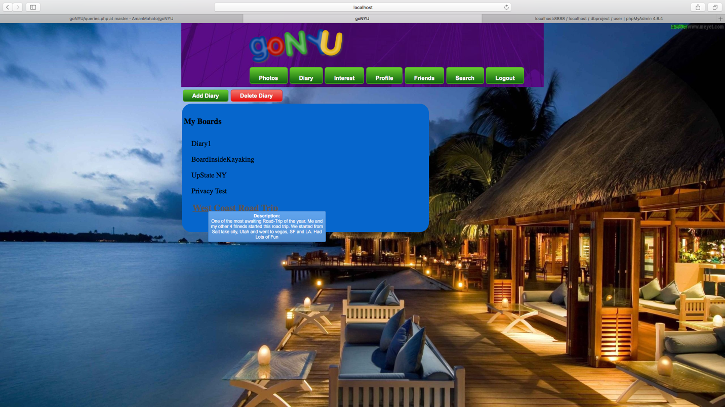

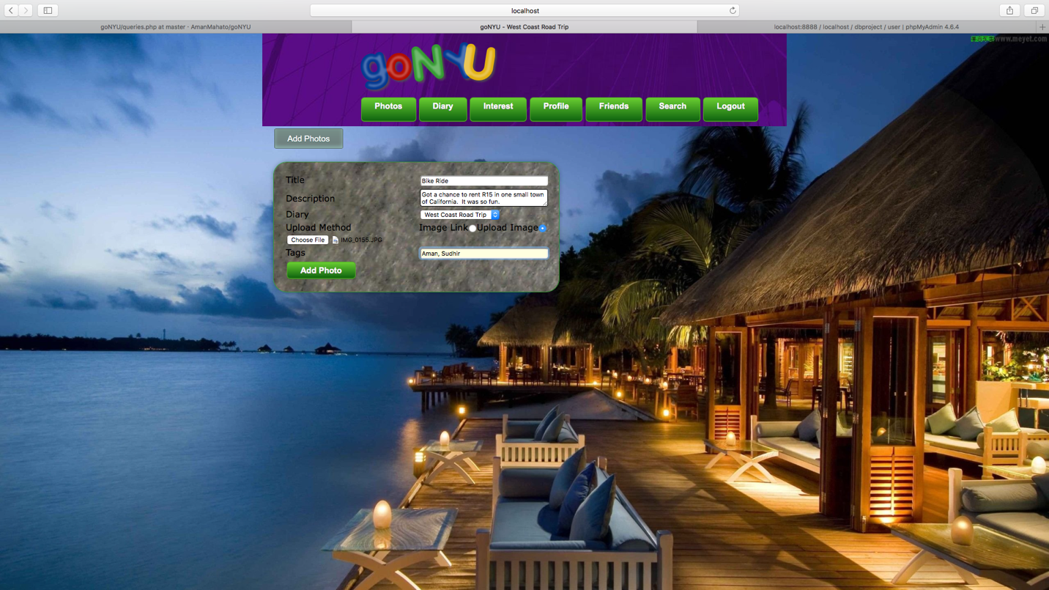

After adding, news feed changes

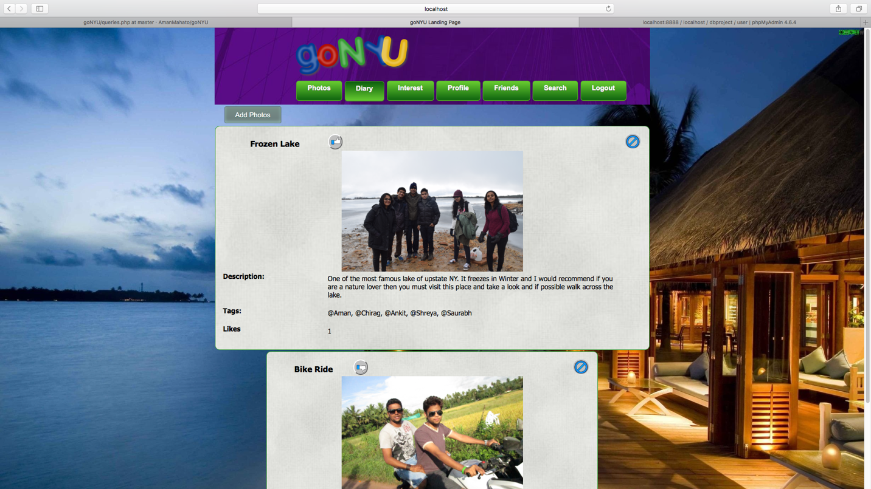

Adding to the particular Diary without entering inside the Diary

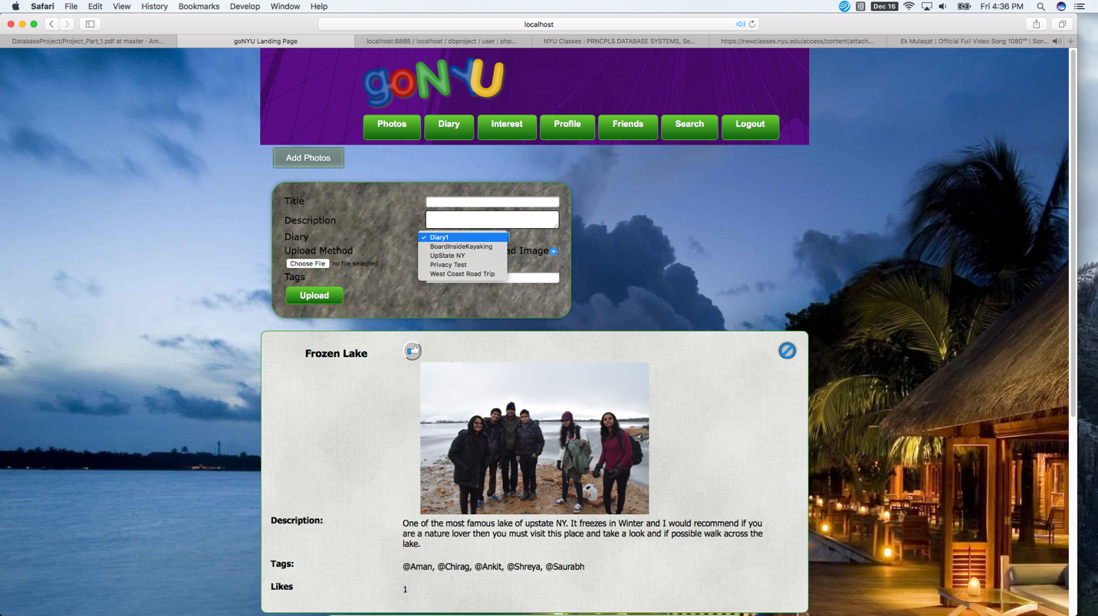

Posting a comment to the Diary

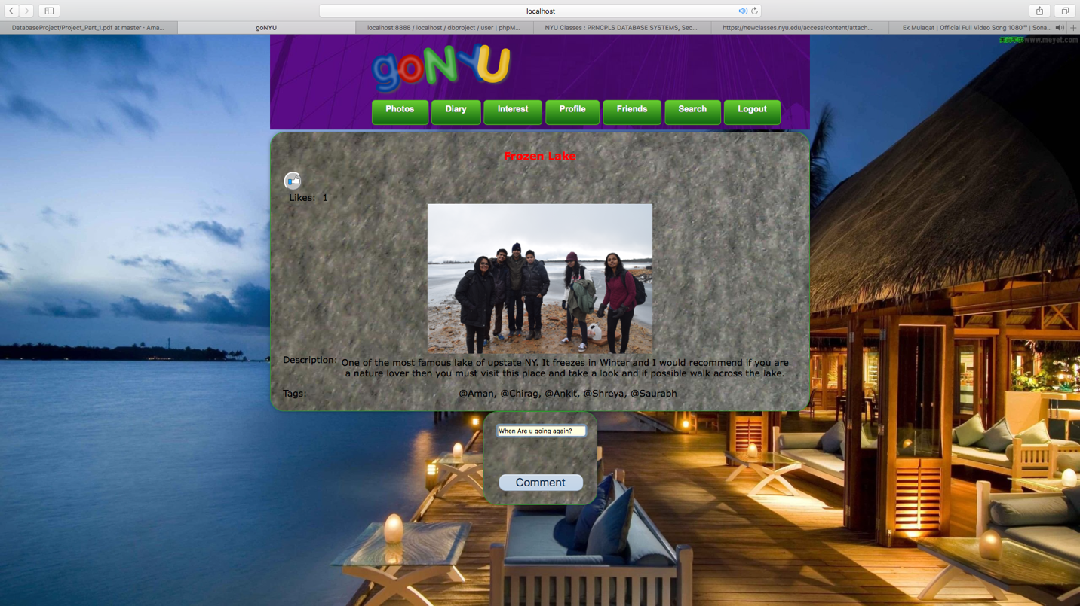

Searching for all the Diary

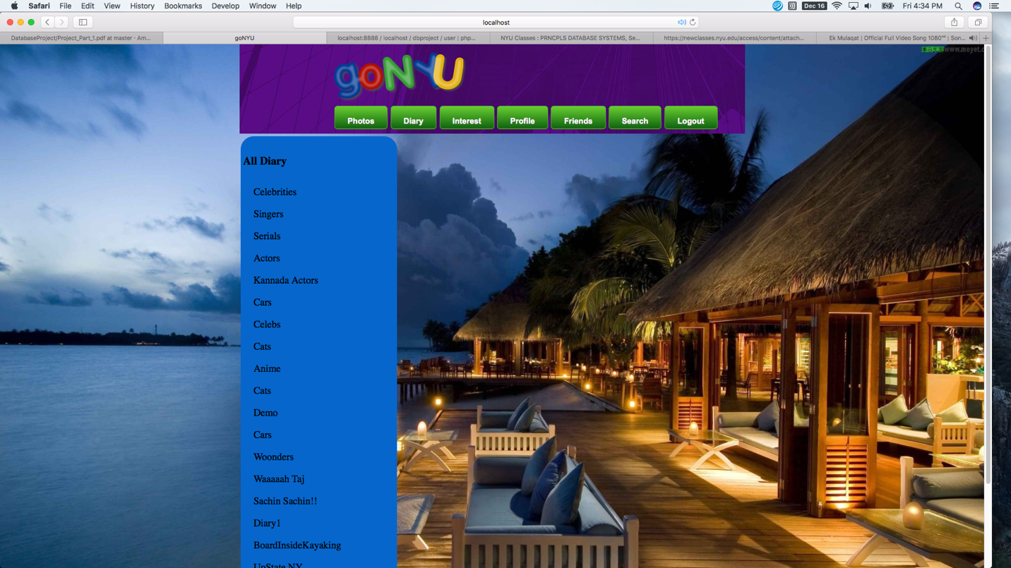

Interest

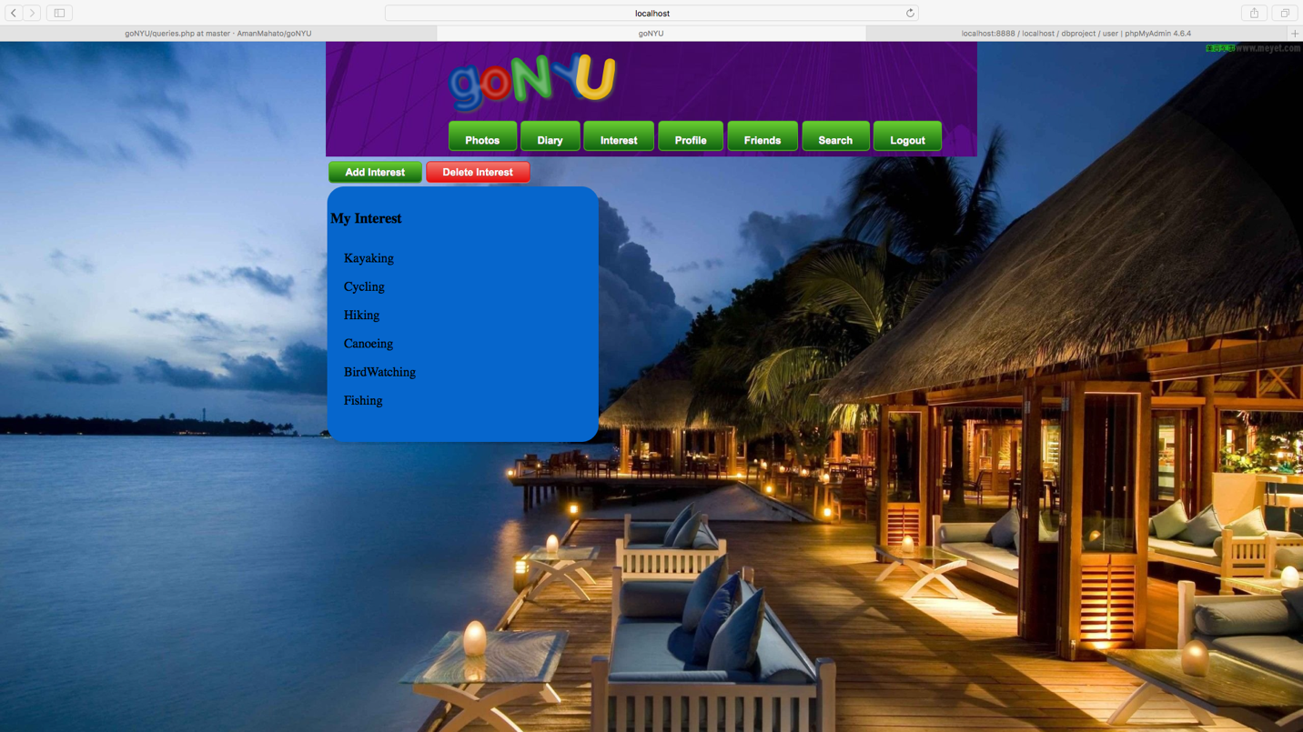

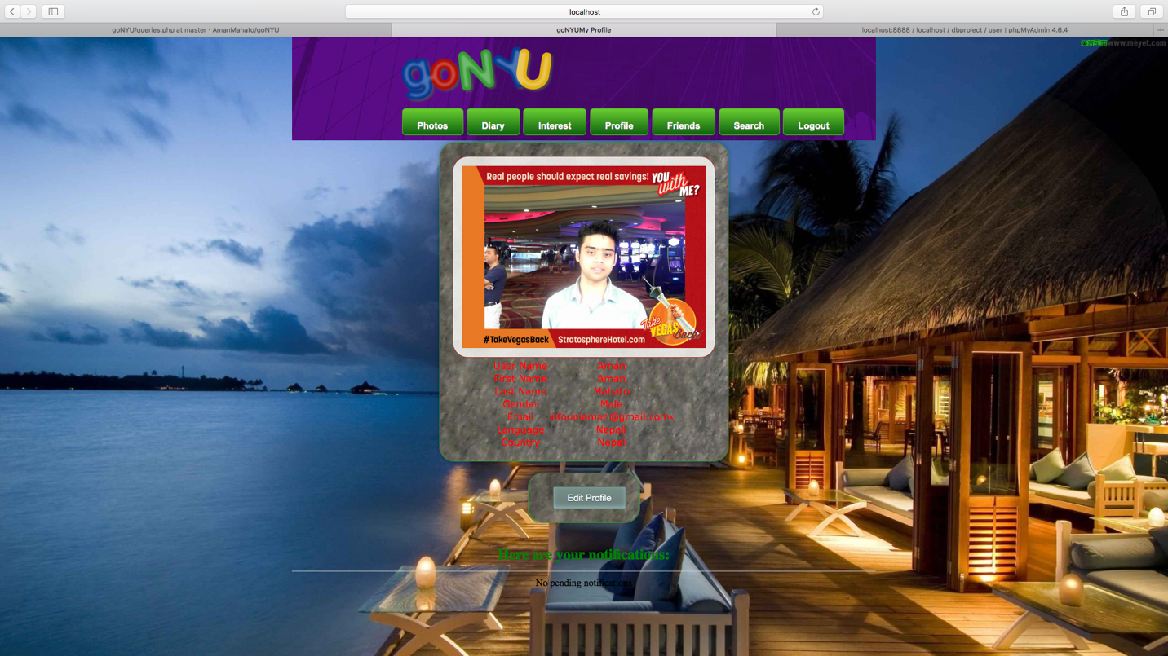

profile

Profile updated

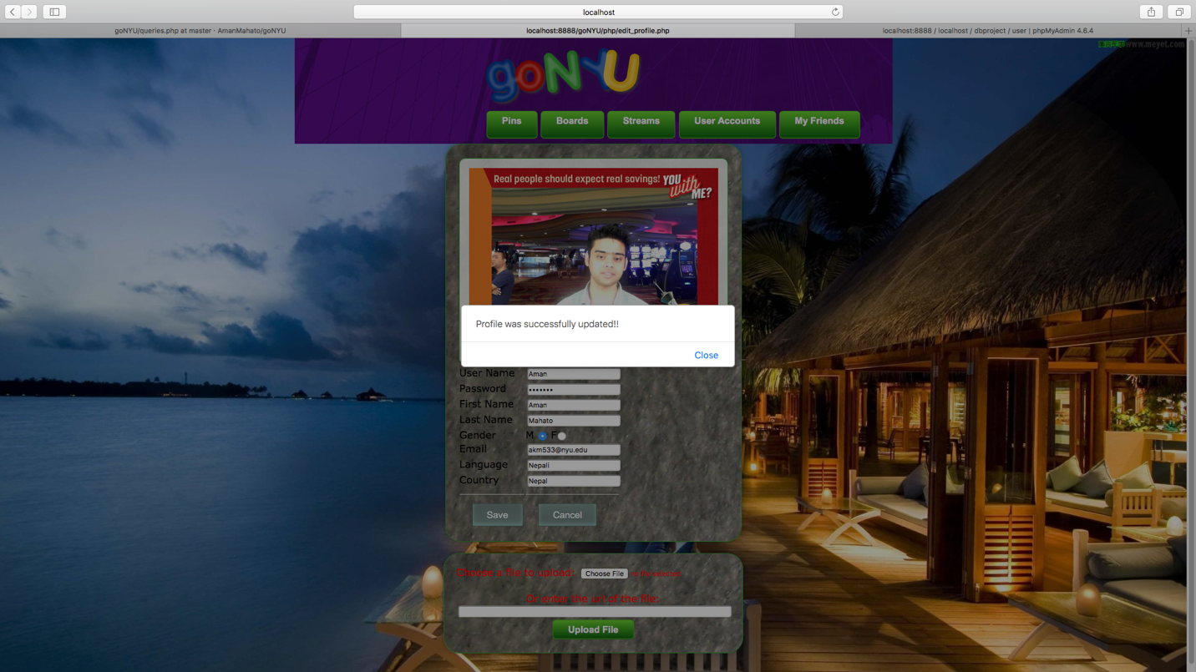

List of All the frens

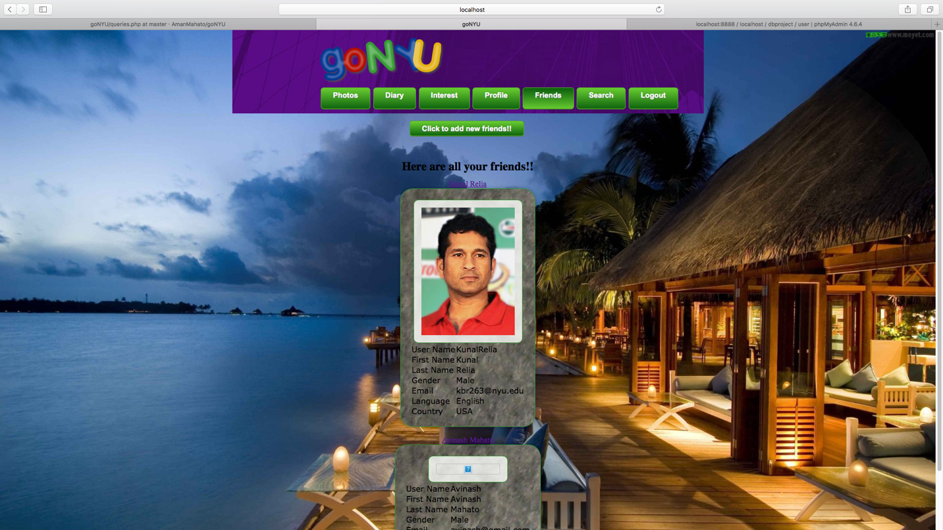

Sending A Fren Request

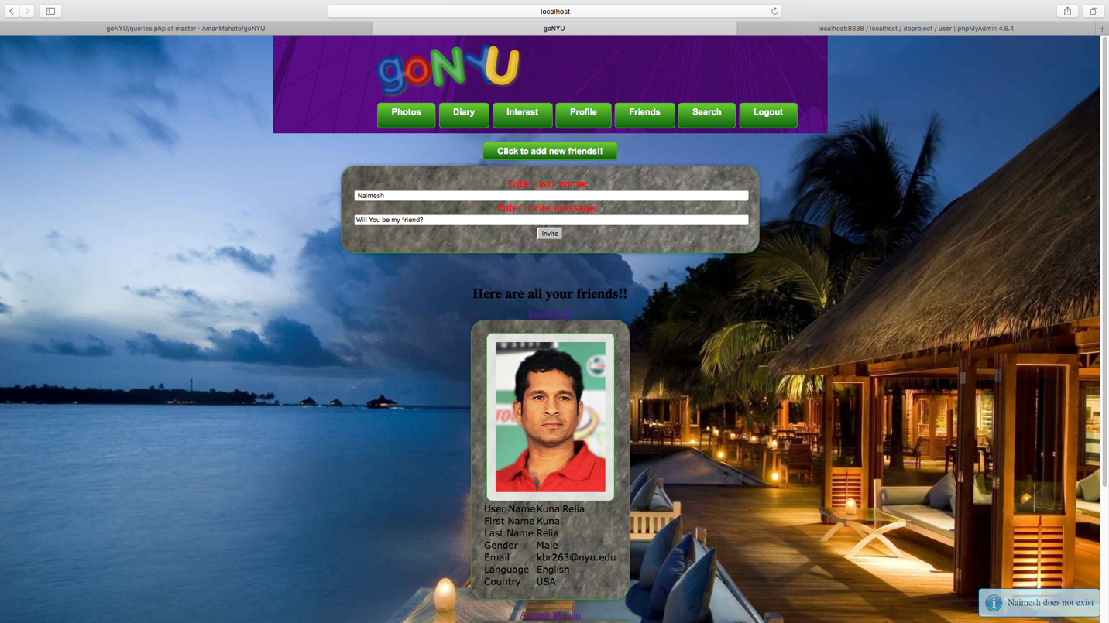

At Receiver End

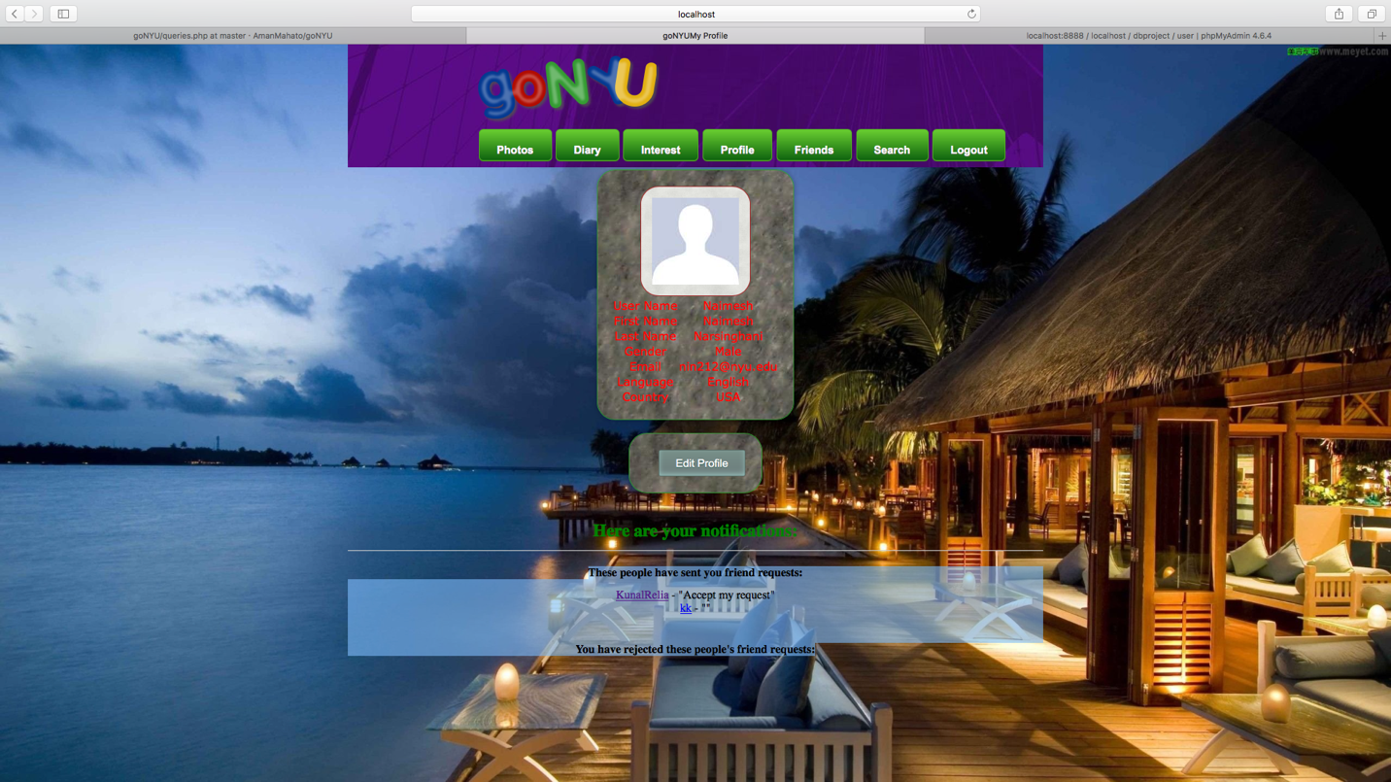

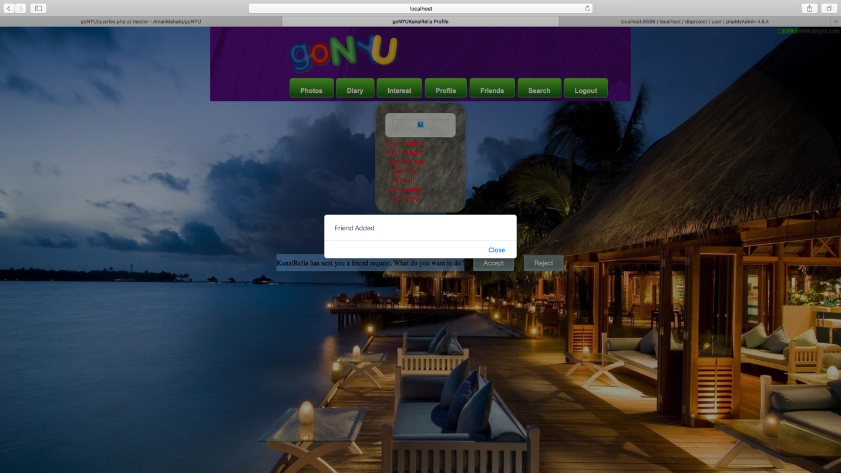

Fren Added to receiver

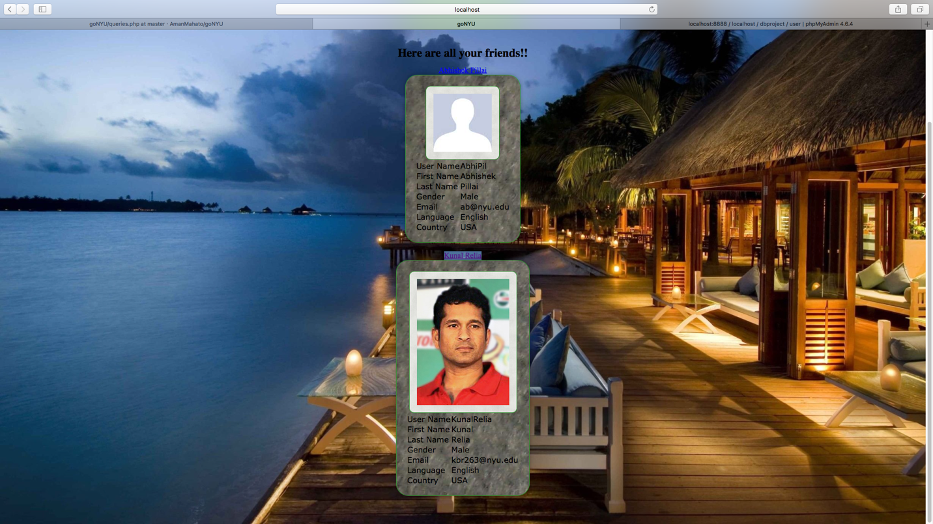

Fren Added to sender

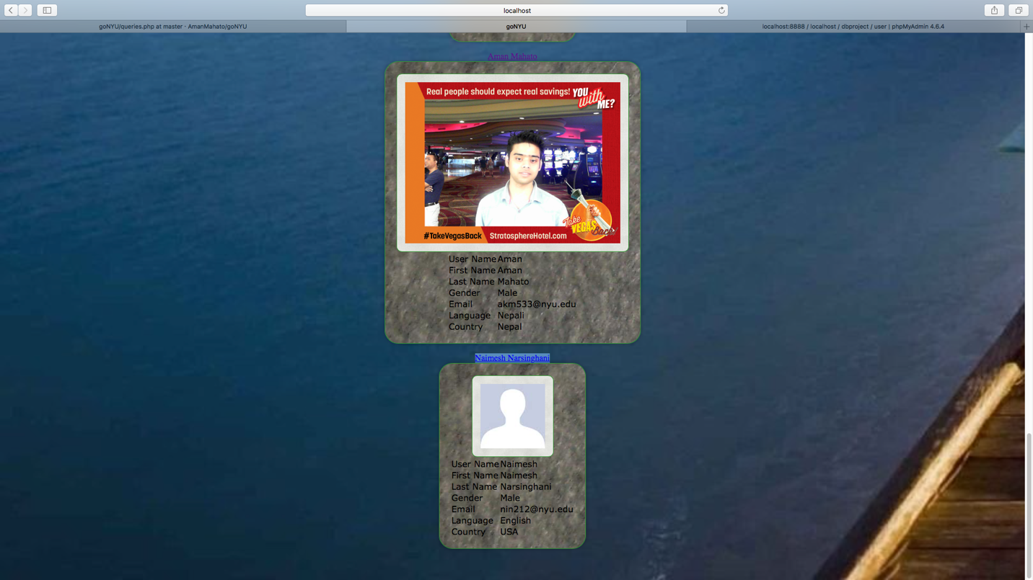

Like and Dislike

Some Extra Features

Future Scope

Conclusion